CloudFront & Route 53
1.Configure VPC peering in cross regions
Steps
- Create VPC-A in Region 1 (e.g., Mumbai) with CIDR 10.0.0.0/16.
- Create VPC-B in Region 2 (e.g., N. Virginia) with CIDR 192.168.0.0/16.
- In the VPC Console, go to Peering Connections and click Create Peering Connection.
- Enter a name for the peering connection.
- Select:
  - Requester VPC: VPC-A
  - Accepter Region: Region 2
  - Accepter VPC: VPC-B
- Click Create Peering Connection.
- Switch to Region 2 and open Peering Connections.
- Select the pending peering request and click Actions → Accept Request.
- In Region 1, open the route table associated with VPC-A.
- Add a route:
  - Destination: 192.168.0.0/16
  - Target: VPC Peering Connection
- Save the route.
- In Region 2, open the route table associated with VPC-B.
- Add a route:
  - Destination: 10.0.0.0/16
  - Target: VPC Peering Connection
- Save the route.
- Update the security group of resources in VPC-A to allow traffic from 192.168.0.0/16.
- Update the security group of resources in VPC-B to allow traffic from 10.0.0.0/16.
- Launch EC2 instances in both VPCs (optional for testing).
- Test connectivity using the private IP addresses of the instances.
- Verify that the VPC peering connection status is Active and communication between VPCs is successful.

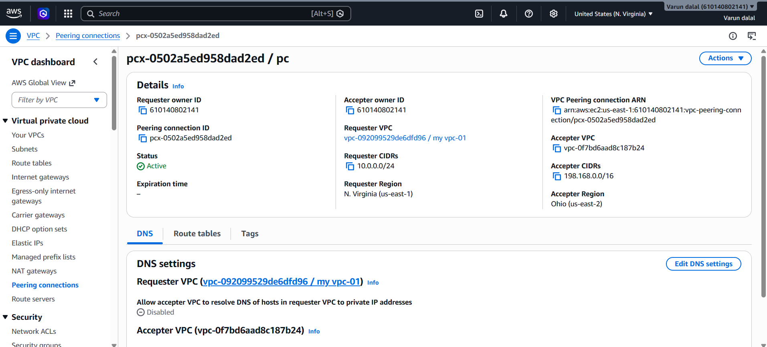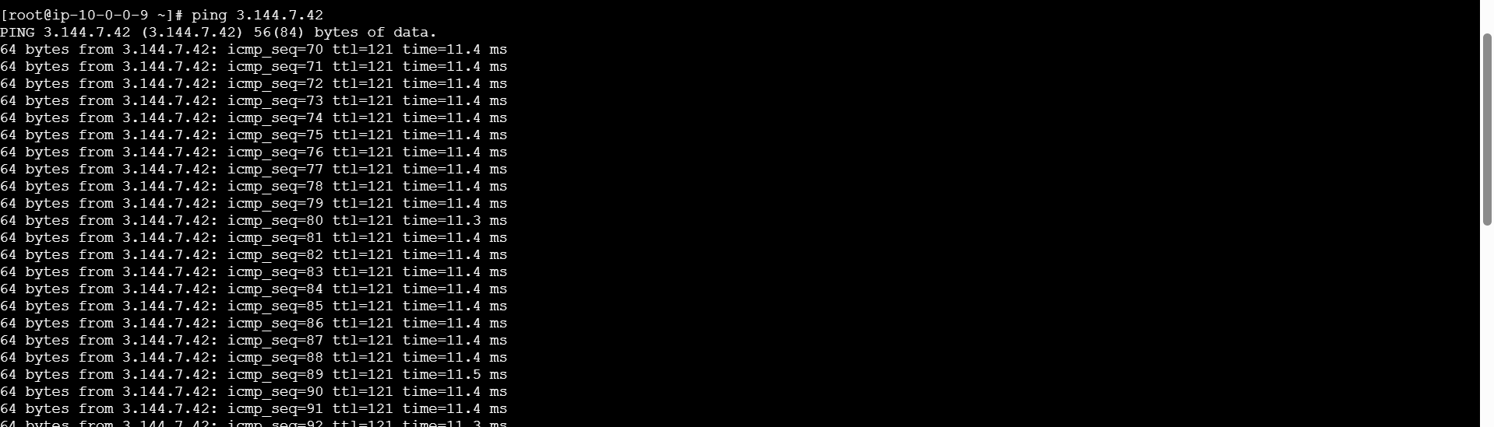
2.Purchase one domain from GoDaddy.
Purchase a Domain from GoDaddy – Step by Step
- Open the GoDaddy website.
- Sign in to your GoDaddy account or create a new account if you do not have one.
- In the search bar on the homepage, enter the domain name you want to purchase.
- Click Search Domain.
- Review the search results to check if the domain is available.
- Select the desired domain name and click Add to Cart.
- Choose the registration period (e.g., 1 year, 2 years, etc.).
- Review any additional services offered (such as privacy protection, email, or hosting) and select them if required.
- Click Continue to Cart.
- Review your order summary.
- Click Proceed to Checkout.
- Enter your billing and payment information.
- Review the final order details.
- Click Complete Purchase to buy the domain.
- After the purchase is successful, navigate to My Products in your GoDaddy account.
- Verify that the purchased domain appears in your domain list.
- Open the domain settings page to manage DNS records, nameservers, and other domain configurations.
Validation
- Log in to your GoDaddy account.
- Navigate to My Products.
- Confirm that the purchased domain is listed under Domains.
- Verify that the domain status is Active and available for DNS configuration.

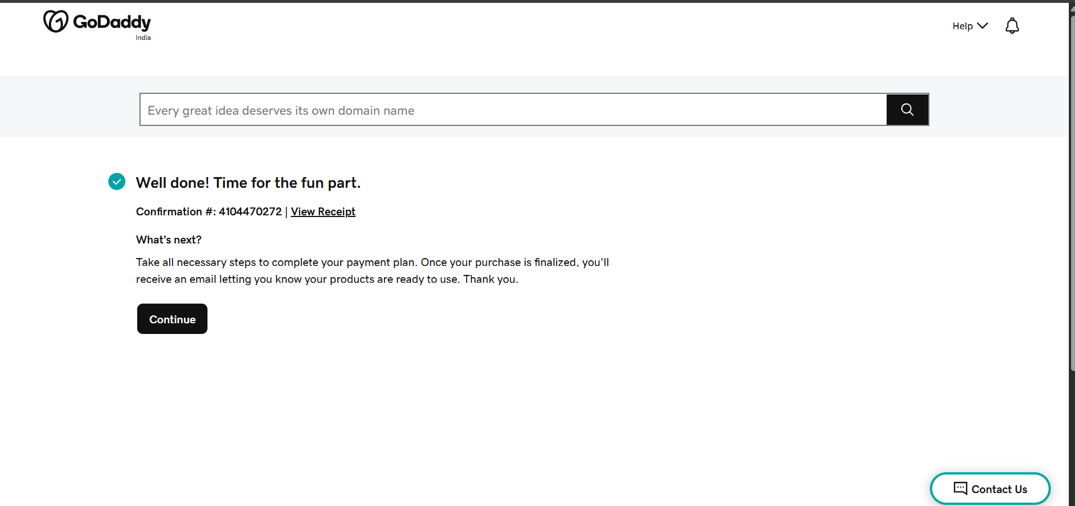
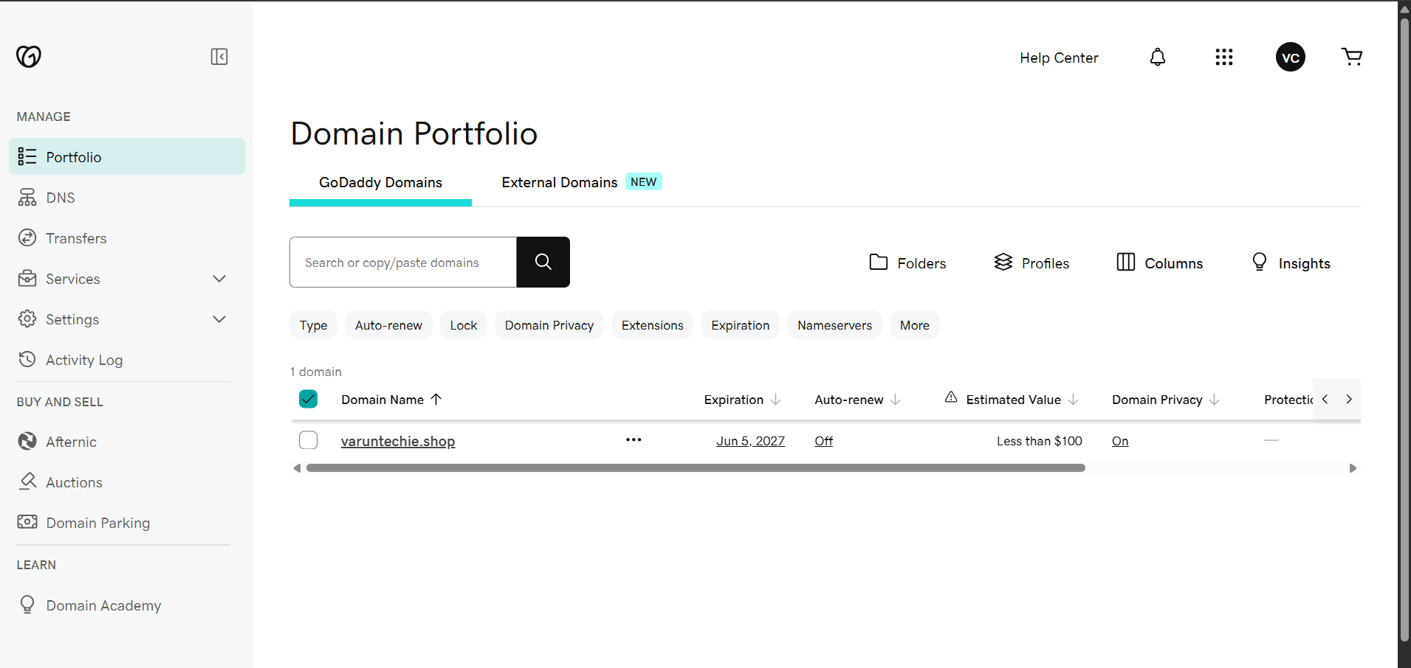

3. Deploy a Static Website in Amazon S3
Objective
Host a static website using Amazon S3 by uploading HTML files and enabling static website hosting. This allows users to access the website through a public S3 website endpoint.
Step 1: Create an S3 Bucket
- Open the AWS Management Console.
- Navigate to S3.
- Click Create bucket.
- Enter a unique bucket name (e.g., my-static-website-12345).
- Choose a Region.
- Uncheck Block all public access.
- Acknowledge the warning.
- Click Create bucket.

Step 2: Enable Static Website Hosting
- Open the S3 bucket.
- Go to Properties.
- Scroll to Static website hosting.
- Click Edit.

- Select Enable.
- Hosting type: Host a static website.
- Index document: index.html.
- Click Save changes.

Step 3: Configure Bucket Policy
Go to Permissions → Bucket Policy and add JSON

Step 4: Verify Public Access
- Go to Properties.
- Copy the Bucket website endpoint URL.
- Open the URL in a browser.

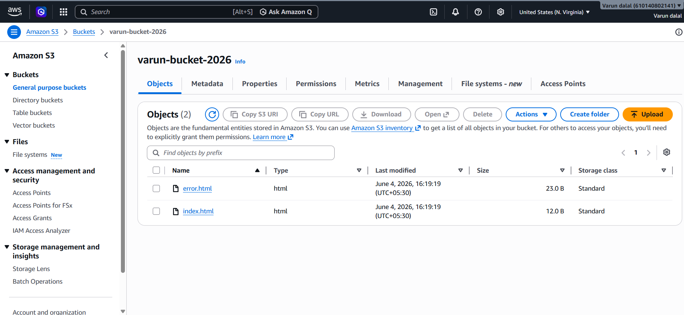


Validation
After saving the policy and enabling static website hosting:
- Go to Properties.
- Copy the Bucket website endpoint.
- Open it in a browser.

4.Create a CDN (CloudFront) and Attach an SSL Certificate
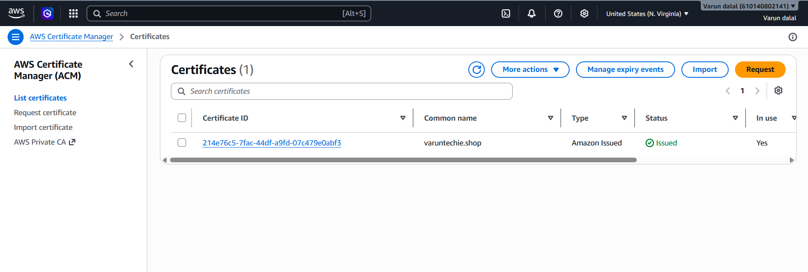
Objective
Configure an Amazon CloudFront distribution as a CDN for your S3 static website and secure it using an SSL certificate from AWS Certificate Manager (ACM).
Step 1: Request an SSL Certificate
Important: CloudFront requires the ACM certificate to be created in US East (N. Virginia) - us-east-1.
- Switch to US East (N. Virginia) region.
- Open AWS Certificate Manager (ACM).
- Click Request certificate.
- Select Request a public certificate.
- Enter your domain name:
  - example.com
  - or www.example.com
- Select DNS validation.
- Click Request.
- Create the DNS records in your DNS provider (e.g., Route 53).
- Wait until the certificate status becomes Issued.
Step 2: Create a CloudFront Distribution
- Open CloudFront.
- Click Create Distribution.
- Under Origin Domain, select your S3 bucket.
Configure:
- Viewer Protocol Policy: Redirect HTTP to HTTPS
- Allowed HTTP Methods: GET, HEAD
- Default Root Object: index.html
Step 3: Attach the SSL Certificate
Under Settings:
- Alternate Domain Name (CNAME):
  - www.example.com
- Custom SSL Certificate:
  - Select the ACM certificate created in us-east-1.
- Security Policy:
  - TLSv1.2_2021 (recommended)
- Click Create Distribution.
Step 4: Configure DNS
If using Route 53:
- Open Route 53.
- Select your hosted zone.
- Create an A Record.
- Enable Alias.
- Select:
  - Alias to CloudFront Distribution
  - Your CloudFront distribution
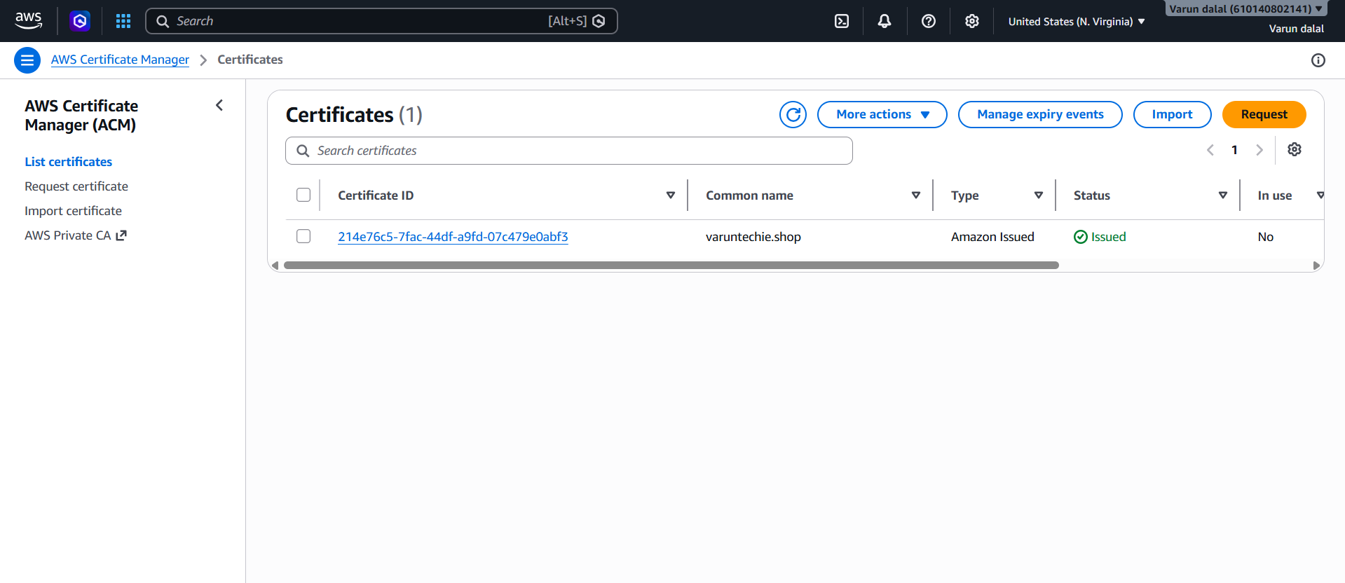

5.Create a Route 53 hosted zone and map the domain with the CDN.
Task: Create a Route 53 Hosted Zone and Map the Domain with CloudFront CDN
Objective
Create a Route 53 hosted zone for a custom domain and map it to a CloudFront distribution so the website can be accessed using the domain name.

Step 1: Create a Hosted Zone
- Sign in to the AWS Management Console.
- Navigate to Route 53.
- Select Hosted Zones.
- Click Create Hosted Zone.
- Enter:
  - Domain Name: yourdomain.com
  - Type: Public Hosted Zone
- Click Create Hosted Zone.

Step 2: Note the Route 53 Name Servers
- Open the newly created hosted zone.
- Locate the NS (Name Server) record.
- Copy all four name server values.
Example:
ns-123.awsdns-45.com
ns-456.awsdns-67.net
ns-789.awsdns-89.org
ns-101.awsdns-12.co.uk

Step 3: Update Name Servers at the Domain Registrar
- Log in to your domain registrar (e.g., GoDaddy).
- Open Domain Management.
- Select your domain.
- Go to Nameservers.
- Choose Custom Nameservers.
- Replace the existing nameservers with the Route 53 nameservers copied earlier.
- Save the changes.

Step 4: Create an ACM Certificate
- Navigate to AWS Certificate Manager (ACM) in the N. Virginia (us-east-1) region.
- Click Request a Certificate.
- Select Request a Public Certificate.
- Add:
  - yourdomain.com
  - www.yourdomain.com
- Choose DNS Validation.
- Complete the request.
- Create the DNS validation records in Route 53.
- Wait until the certificate status changes to Issued.

Step 5: Configure CloudFront Distribution
- Navigate to CloudFront.
- Open your distribution.
- Click Edit.
- Under Alternate Domain Names (CNAMEs) add:
  - yourdomain.com
  - www.yourdomain.com
- Under Custom SSL Certificate, select the ACM certificate.
- Save the changes.
- Wait for the distribution status to become Deployed.

Step 6: Create an Alias Record for the Root Domain
- Return to Route 53.
- Open your hosted zone.
- Click Create Record.
- Configure:
  - Record Type: A
  - Record Name: Leave blank (root domain)
  - Alias: Enabled
  - Route Traffic To: Alias to CloudFront Distribution
- Select your CloudFront distribution.
- Click Create Records.

Step 7: Create a Record for WWW
- Click Create Record.
- Configure:
  - Record Type: A
  - Record Name: www
  - Alias: Enabled
  - Route Traffic To: Alias to CloudFront Distribution
- Select the same CloudFront distribution.
- Click Create Records.

Step 8: Wait for DNS Propagation
- Allow a few minutes for Route 53 records to propagate.
- Verify that the domain resolves correctly.

Validation
- Open:
  - https://yourdomain.com
  - https://www.yourdomain.com
- Confirm:
  - The website loads successfully.
  - HTTPS is working with a valid SSL certificate.
  - The content is served through CloudFront.
  - Both root and www domains resolve to the website.
Validation Statement
A Route 53 hosted zone was successfully created, and the domain was mapped to the CloudFront distribution using Alias records. The ACM certificate was attached to CloudFront, enabling secure HTTPS access. The website is accessible through both the root domain and www subdomain, with content being served successfully through the CDN.
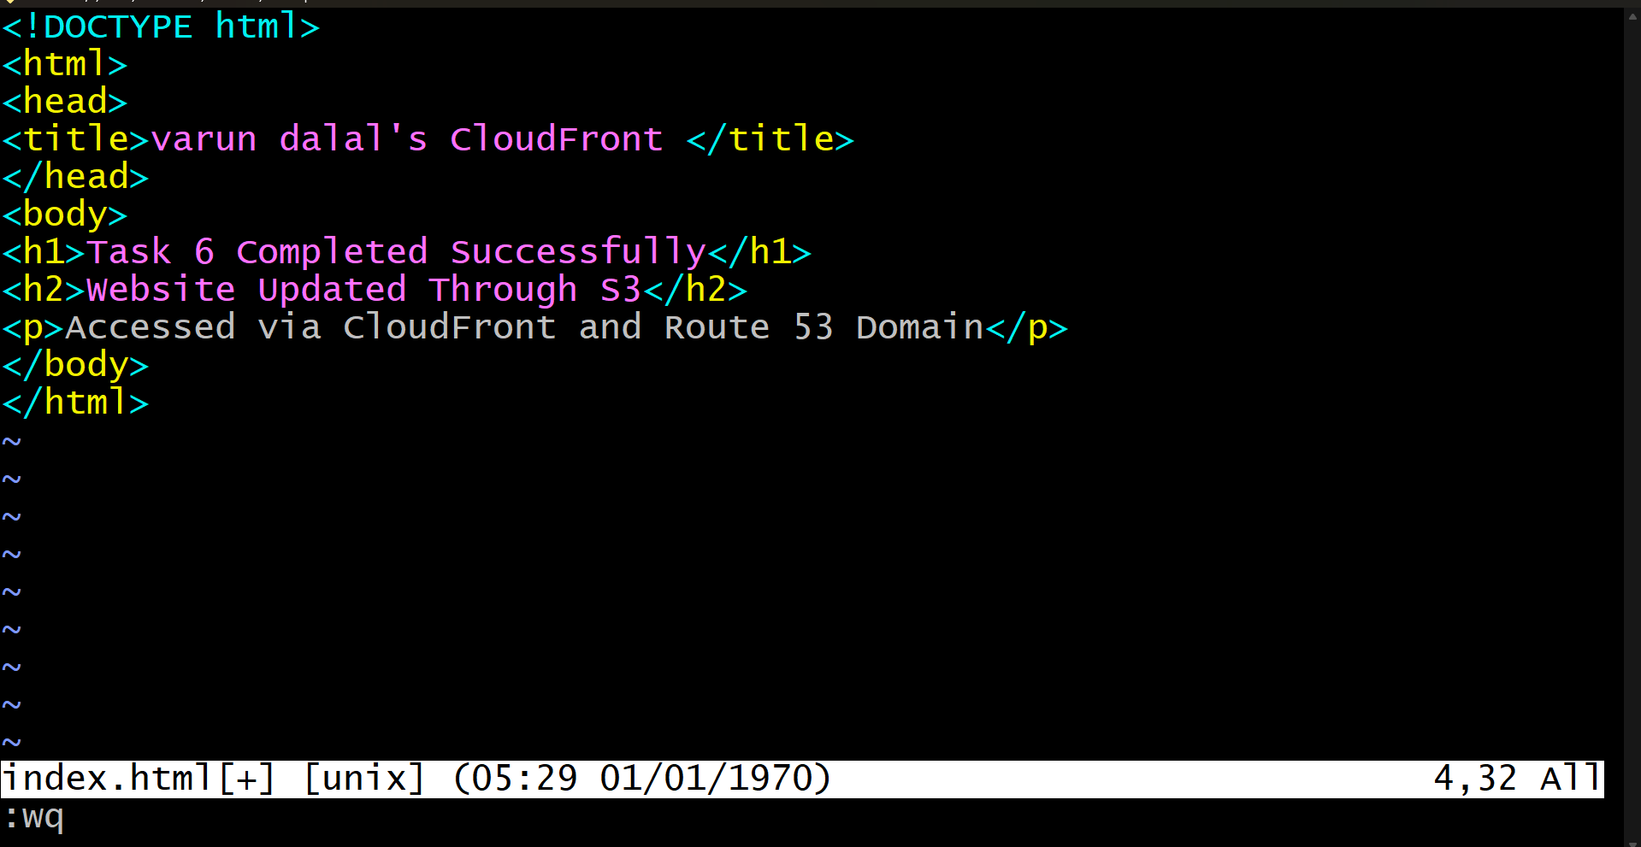
6.Update the index.html in the S3 bucket and ensure the updated file is accessible using the domain name
Task: Update the index.html in the S3 Bucket and Ensure the Updated File is Accessible Using the Domain Name
Step 1: Open the S3 Bucket
- Sign in to the AWS Management Console.
- Navigate to S3.
- Open the bucket hosting your static website.
Step 2: Edit the Existing index.html
- Locate the index.html file in the bucket.
- Download and edit it locally, or create a new version with the required changes.
- Save the file.
Step 3: Upload the Updated File
- In the S3 bucket, click Upload.
- Select the updated index.html file.
- Upload it and replace the existing file.
Step 4: Create a CloudFront Invalidation
- Navigate to CloudFront.
- Select your distribution.
- Open the Invalidations tab.
- Click Create Invalidation.
- Enter /* as the path.
- Click Create Invalidation.
Step 5: Wait for Invalidation Completion
- Monitor the invalidation status.
- Wait until the status changes to Completed.
Step 6: Verify Website Accessibility
- Open your custom domain in a web browser.
- Ensure the website loads successfully.
Step 7: Confirm the Updated Content
- Refresh the page.
- Verify that the updated content from index.html is displayed.
- If the old content appears, clear the browser cache or open the website in an Incognito/Private window.

Validation
- The updated index.html file was uploaded successfully to the S3 bucket.
- CloudFront cache invalidation completed successfully.
- The website is accessible using the configured domain name.
- The updated content is displayed correctly through the custom domain.

